**Weeping Willow Tree & Bird Mirror**

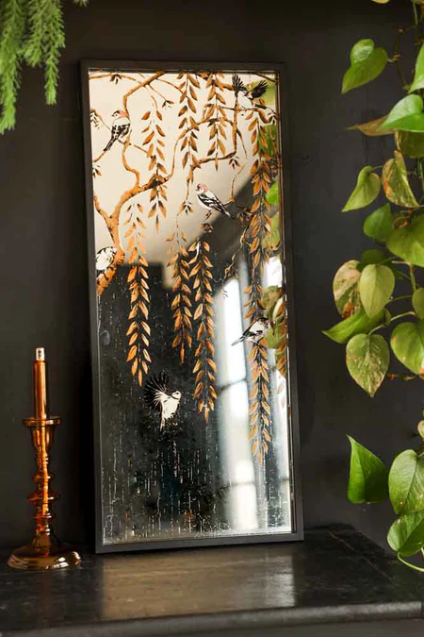The **Weeping Willow Tree & Bird Mirror** is a captivating piece that brings nature's tranquility into your home. Featuring a beautifully detailed weeping willow tree, with its elegant, cascading branches, and delicate birds perched among its leaves, this mirror creates a serene and harmonious atmosphere. The graceful design evokes a sense of peace, making it the perfect addition to living rooms, bedrooms, or even entryways. With its reflective surface surrounded by intricate artwork, this mirror not only serves as a functional element but also adds a touch of nature-inspired elegance and calm to your decor.